27.76: a)
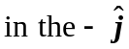 direction. To keep the loop in place, you must provide a torque in the 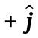 direction.
b) in the 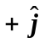 direction you must provide a torque in the 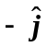 direction to keep the loop in place.
c) If the loop was pivoted through its center, then there would be a torque on both sides of the loop parallel to the rotation axis. However, the lever arm is only half as large, so the total torque in each case is identical to the values found in parts (a) and (b).

